**FINAL PAPER**

**SUBMITTED TO:**

**SIR FAHAD ZIA**



**SUBMITTED BY:**

**MUHAMMAD HUZAIFA BIN SARFARAZ**

**ID:16894**

**DEPARTMENT OF COMPUTER SCIENCE (BS SE)**

**CITY UNIVERSITY OF SCIENCE AND INFORMATION TECHNOLOGY**

**PESHAWAR**

**July 4, 2025**

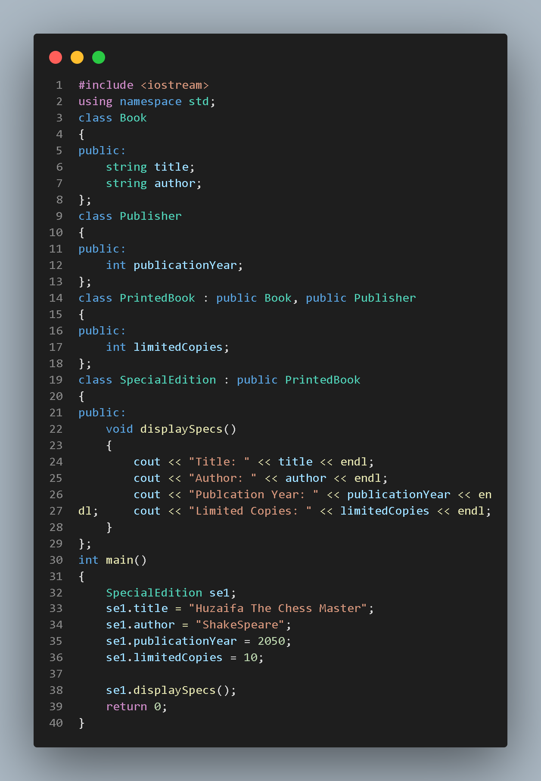**Questin1**

**Out put:**

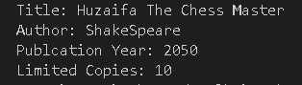

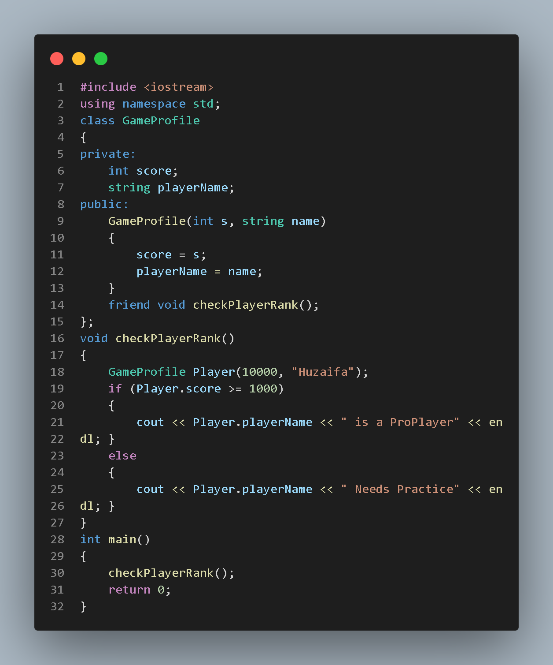QUESTION 2:

**Output:**



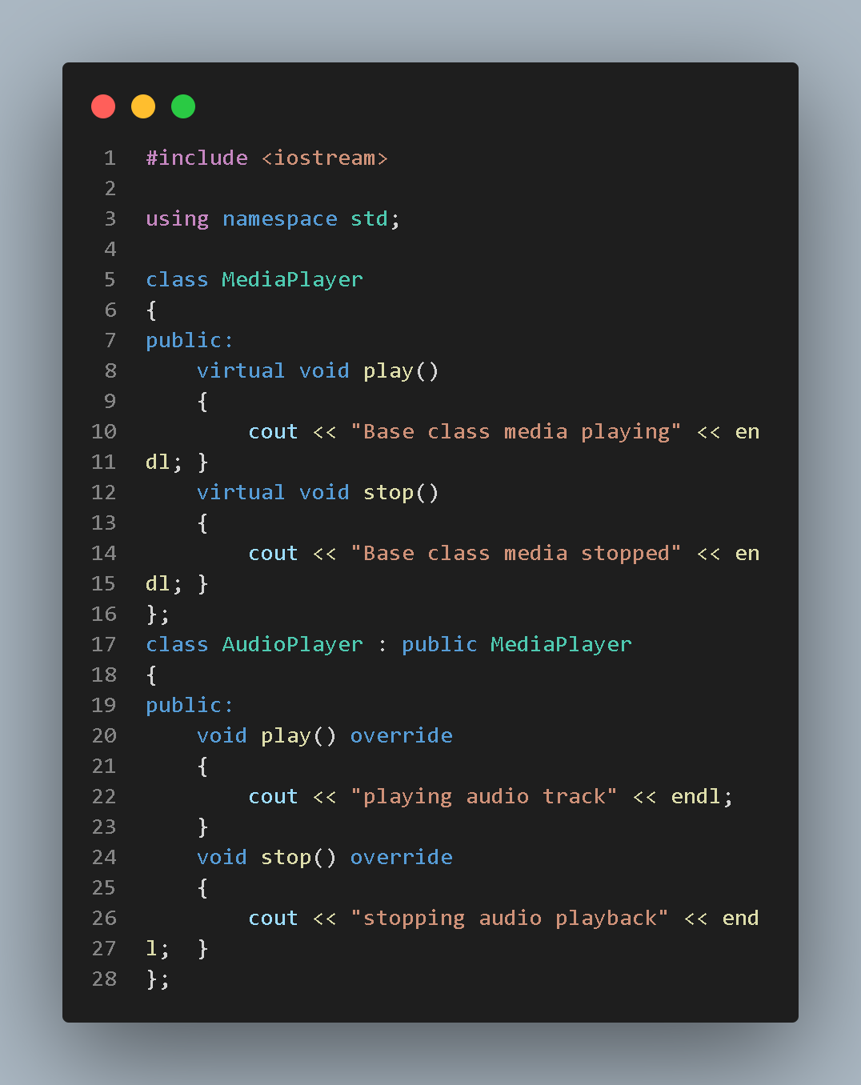**QUESTION 3**

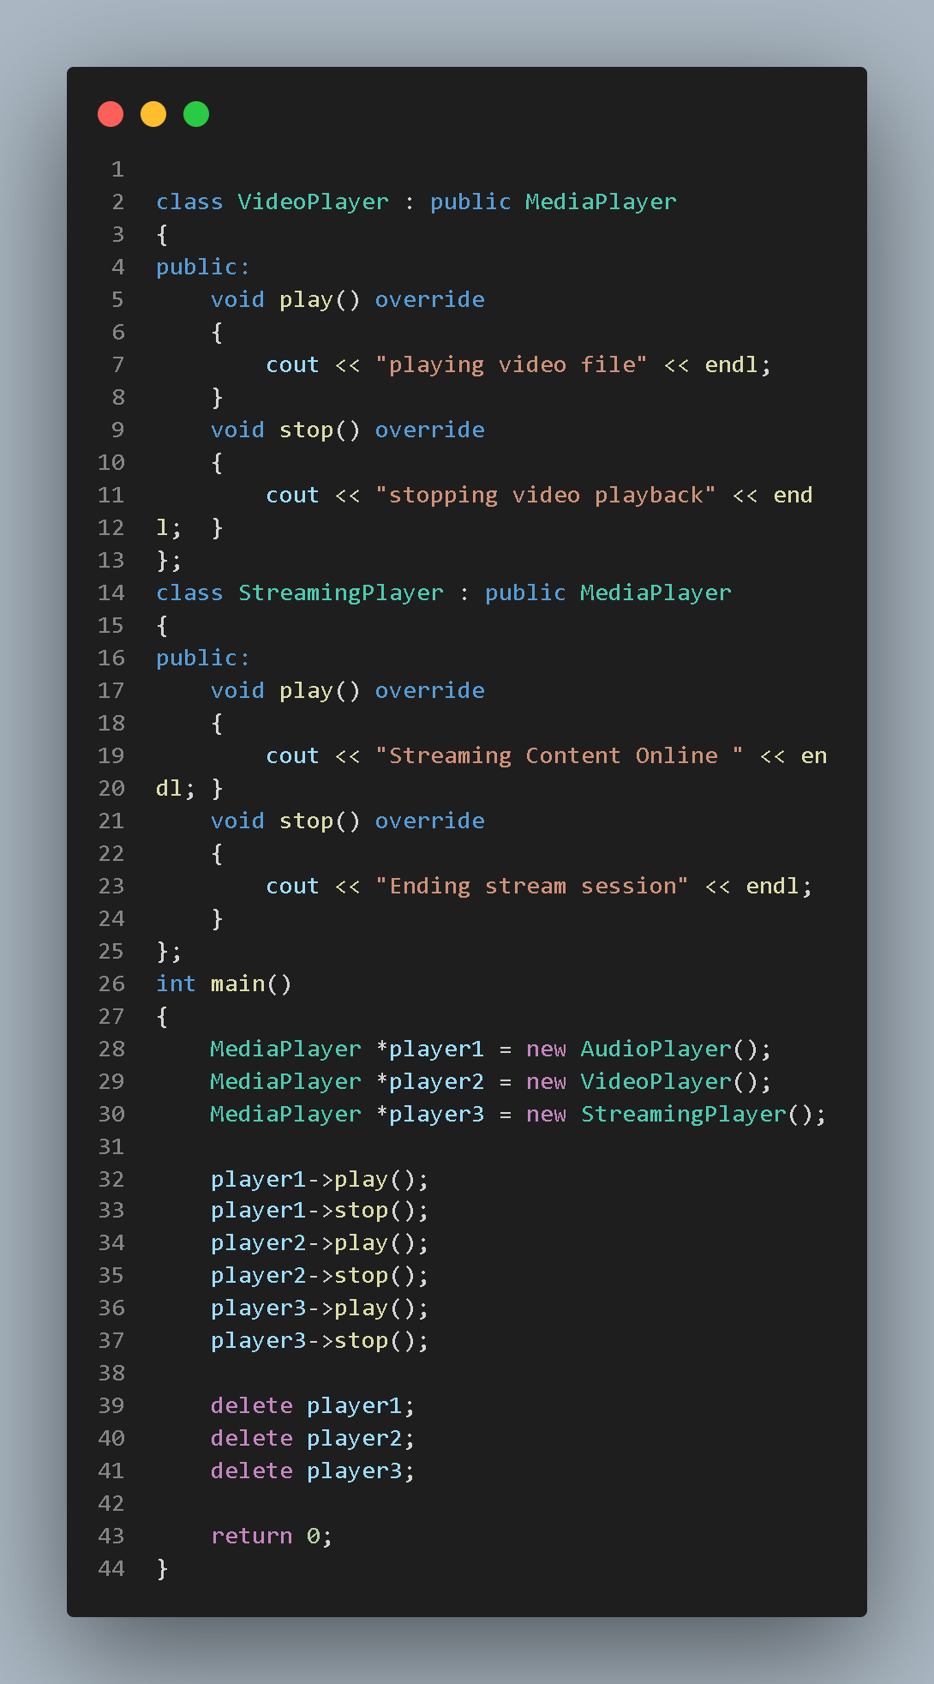

**OUTPUT:**

